|  |  |  |  |  |  |  |  |  |  |
| --- | --- | --- | --- | --- | --- | --- | --- | --- | --- |
| **ANNEX 08**  **SHOTGUN AND AMMUNITION FORM**  ***TO BE COMPLETED ONLY BY ATHLETES WHO DO NOT POSSES A “EUROPEAN FIREARMS CERTIFICATE”***  **(Please read carefully the note at the bottom of page)** | | | | | | | | | |
| family name |  | | | | first name | | |  | |
| country |  | | | | nationality | | |  | |
| birth date |  | | | | birth place | | |  | |
| place of residence  (city & country) |  | | | | | | | | |
| passport number |  | | | | expiry date | |  | | |
| **Shotguns** | | | | | | | | | |
| manufacturer | | model (if applicable) | | serial number | | | | | gauge/ caliber |
|  | |  | |  | | | | |  |
|  | |  | |  | | | | |  |
| **Ammunition** | | | | | | | | | |
| quantity | | | manufacturer | | | gauge/ caliber | | | |
|  | | |  | | |  | | | |
| Athletes, **NOT holding** a ‘European Firearms Certificate’ must, upon arrival at Larnaca or Paphos airports, present this form to customs (Red Channel), in order to obtain a temporary shotgun, import permit.  European Union Members holding a ‘European Firearms Certificate’ **SHOULD NOT** fill in this form. They must simply check their shotguns through customs (Red Channel) and verify the serial numbers of their weapons only.  The temporary shotgun import permits or the ‘European Firearms Certificates’ must be presented to customs at the time of departure at the airport. | | | | | | | | | |

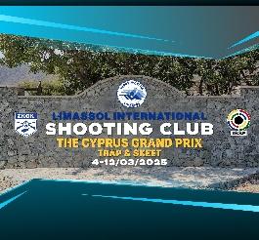

|  |  |
| --- | --- |
| **Date** | **Signature of Athlete or Representative** |